**C program to Calculate 1 + 2 + 3 + 4 + 5 + ... + n series**

#include<stdio.h>

#include<conio.h>

**void** main()

{

**int**i,n,sum=0;

clrscr();

n=10;

**for**(i=1;i<=n;i++)

{

sum+=i;

}

printf("Sum: %d",sum);

getch();

}

**Output**

Sum: 55

## C program to Calculate (1*1) + (2*2) + (3*3) + (4*4) + (5*5) + ... + (n*n) series

## Program to Print Number Series in C

#include<stdio.h>

#include<conio.h>

**void** main()

{

**int**i,n,sum=0;

clrscr();

n=10;

**for**(i=1;i<=n;i++)

{

sum+=i*i;

}

printf("Sum: %d",sum);

getch();

}

## Output

Sum: 385

## C program to Calculate (1) + (1+2) + (1+2+3) + (1+2+3+4) + ... + (1+2+3+4+...+n) series

## Print Number Series

#include<stdio.h>

#include<conio.h>

**void** main()

{

**int**i,j,n,sum=0;

clrscr();

n=10;

**for**(i=1;i<=n;i++)

{

**for**(j=1;j<=i;j++)

{

sum+=j;

}

}

printf("Sum: %d",sum);

getch();

}

## Output

Sum:385

**LCM of two number**

#include<stdio.h>

#include<conio.h>

**void** lcm(**int**,**int**);

**void** main()

{

**int**a,b;

clrscr();

printf("Enter two numbers: ");

scanf("%d %d",&a,&b);

lcm(a,b);

getch();

// return 0;

}

//function to calculate l.c.m

**void** lcm(**int**a,**int** b)

{

**int**m,n;

m=a;

n=b;

**while**(m!=n)

{

**if**(m < n)

{

m=m+a;

}

**else**

{

n=n+b;

}

}

printf("\nL.C.M of %d and %d is: %d",a,b,m);

}

[Download Code](http://www.sitesbay.com/program/code/lcm_of_number)

**Output**

Enter any two number:

3

15

L.C.M of 3 and 15 is: 15

## Program to Print Pascal Triangle in C

The concept of pascal triangle is; Pascal's triangle is a set of numbers arranged in the form of a triangle. Each number in a row is the sum of the left number and right number on the above row. If a number is missing in the above row, it is assumed to be 0. The first row starts with number 1. The following is a Pascal triangle with 5 rows.

Pascal's triangle is a triangular array of the binomial coefficients.

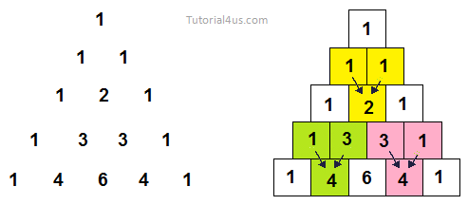

## program to print pascal triangle

#include<stdio.h>

#include<conio.h>

**void** main()

{

**int**bin,p,q,r,x;

clrscr();

bin=1;

q=0;

printf("\n\n\nHow Many Row Do you want to input:");

scanf("%d",&r);

printf("\nPascal's Triangle:\n");

**while**(q<r)

{

**for**(p=40-3*q;p>0;--p)

printf(" ");

**for**(x=0;x<=q;++x)

{

**if**((x==0)||(q==0))

bin=1;

**else**

bin=(bin*(q-x+1))/x;

printf(" ");

printf("%d",bin);

}

printf("\n\n\n");

++q;

}

getch();

}

### Output

